## **Activity File: Exploring Kibana**

* You are a DevOps professional and have set up monitoring for one of your web servers. You are collecting all sorts of web log data and it is your job to review the data regularly to make sure everything is running smoothly.
* Today, you notice something strange in the logs and you want to take a closer look.
* Your task: Explore the web server logs to see if there's anything unusual. Specifically, you will:

⚠ **Heads Up**: These sample logs are specific to the time you view them. As such, your answers will be different from the answers provided in the solution file.

### **Instructions**

1. Add the sample web log data to Kibana.
2. Answer the following questions:  
   * In the last 7 days, how many unique visitors were located in India?
     1. 253

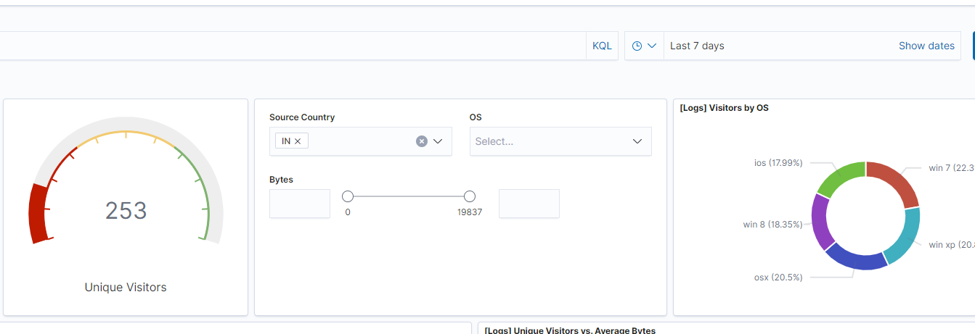

* + In the last 24 hours, of the visitors from China, how many were using Mac OSX?
    1. 8

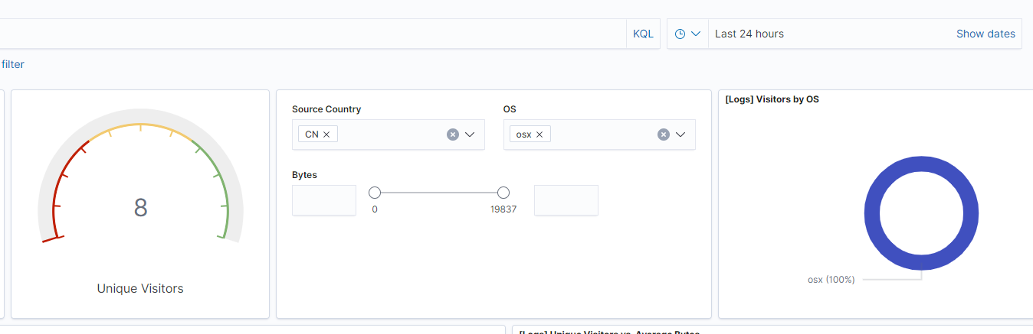

* + In the last 2 days, what percentage of visitors received 404 errors? How about 503 errors?
    1. 0

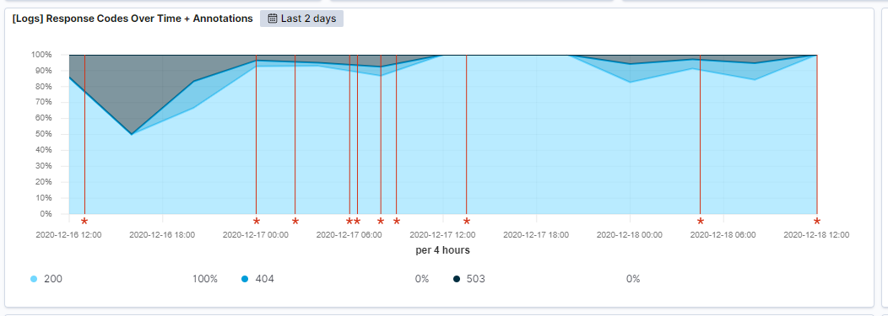

* + In the last 7 days, what country produced the majority of the traffic on the website?
    1. China (Map is off for some reason...sankey chart provides this info clearly)

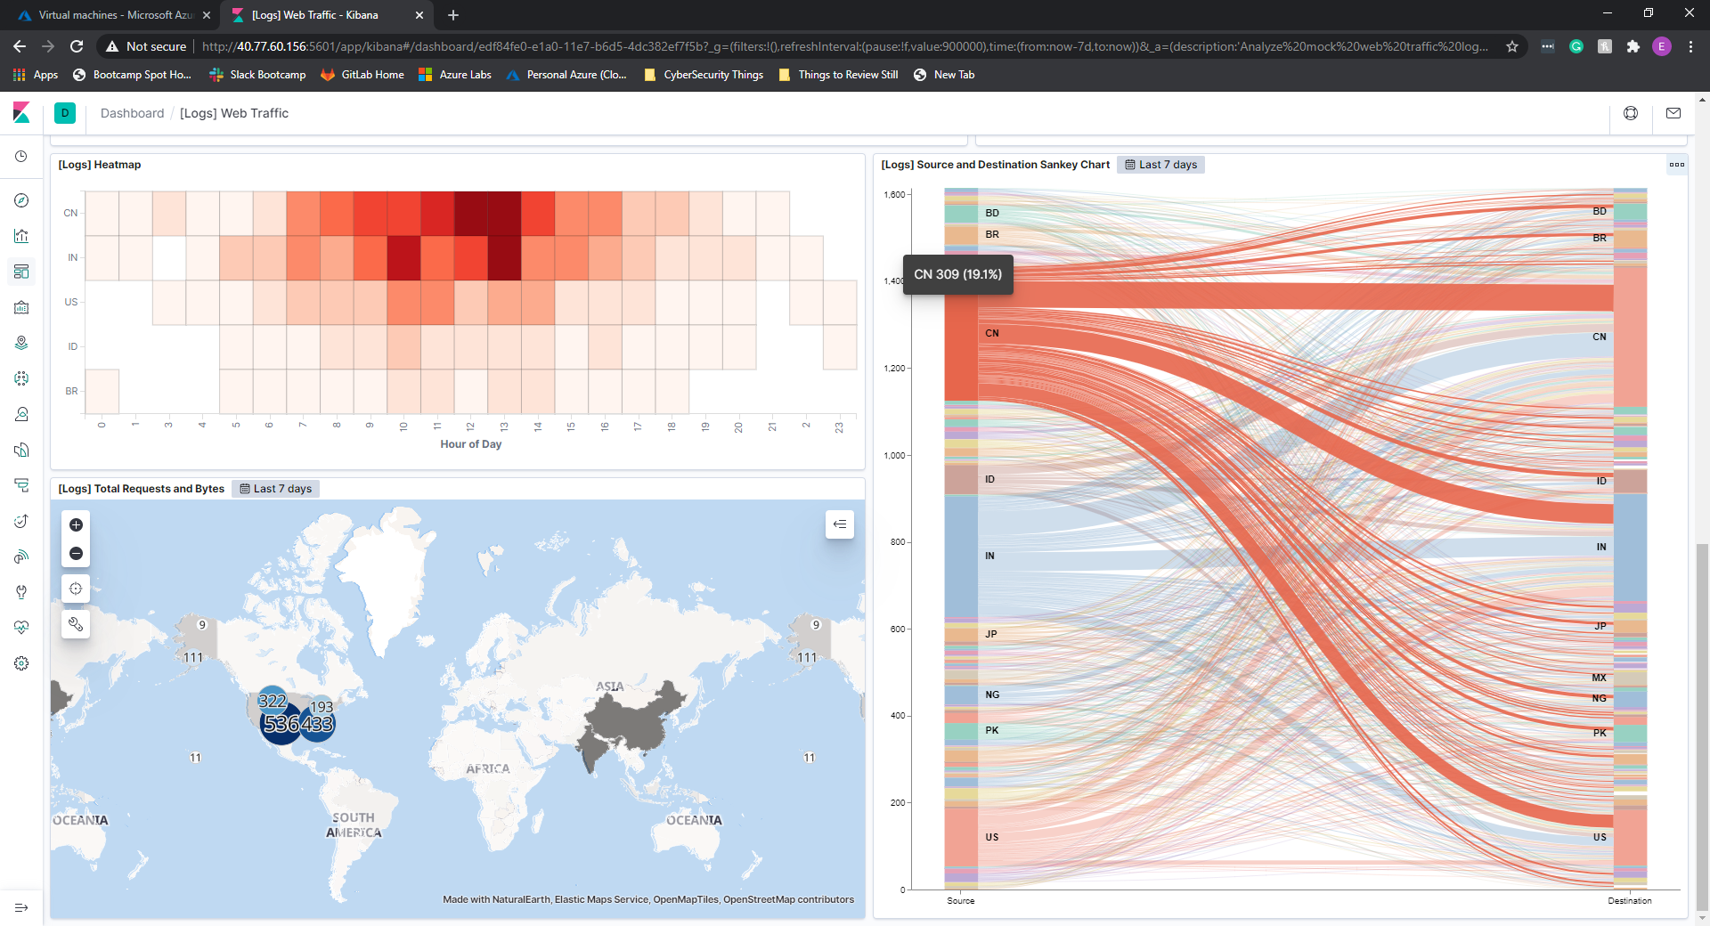

* + Of the traffic that's coming from that country, what time of day had the highest amount of activity?
    1. 12pm and 1pm

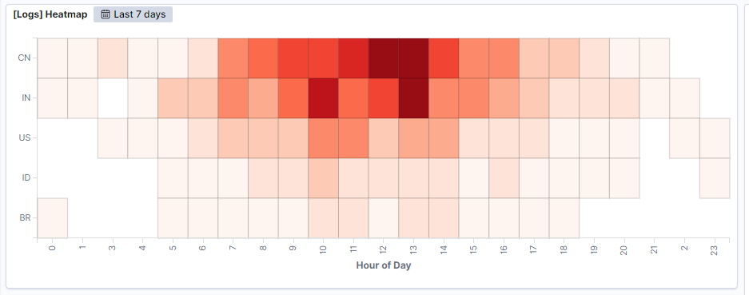

* + List all the types of downloaded files that have been identified for the last 7 days, along with a short description of each file type (use Google if you aren't sure about a particular file type).
    1. gz - Compressed gzip file
    2. css - Define webpage attributes (font, size, color, spacing, etc)
    3. zip - Compressed zip file
    4. deb - Debian software package, usually downloaded by apt
    5. rpm - Red Hat Package Manager file - similar to deb, but for Red Hat linux

1. Now that you have a feel for the data, Let's dive a bit deeper. Look at the chart that shows Unique Visitors Vs. Average Bytes.  
   * Locate the time frame in the last 7 days with the most amount of bytes (activity).

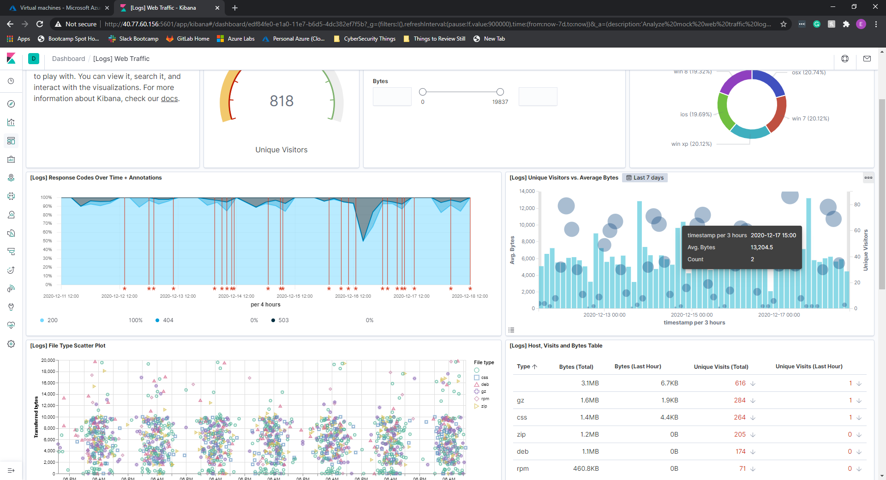

* + In your own words, is there anything that seems potentially strange about this activity?
    1. Seems odd that 2 visitors are using so many bytes of information

1. Filter the data by this event.  
   * What is the timestamp for this event?
     1. 15:25 and 15:55

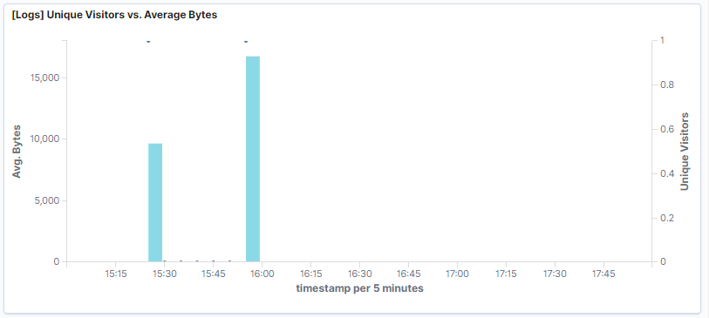

* + What kind of file was downloaded?
    1. rpm and gz files

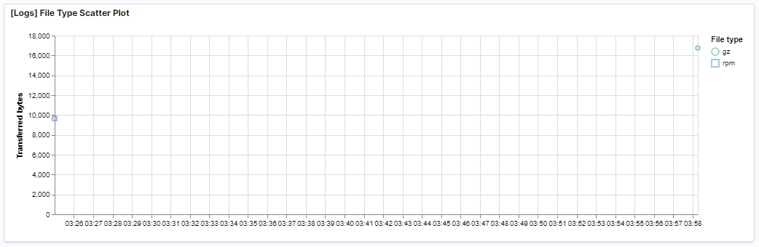

* + From what country did this activity originate?
    1. China and Nigeria

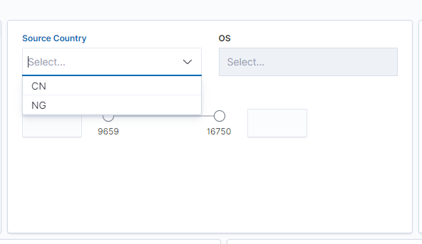

* + What HTTP response codes were encountered by this visitor?
    1. 200

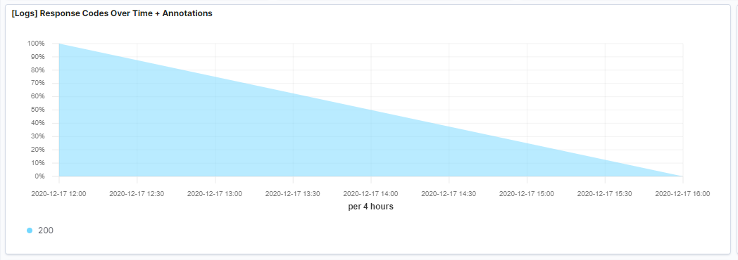

1. Switch to the Kibana Discover page to see more details about this activity.  
   * What is the source IP address of this activity?
     1. 1.145.31.121 and 74.184.0.64

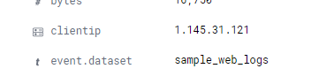

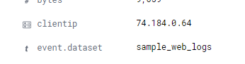

* + What are the geo coordinates of this activity?
    1. 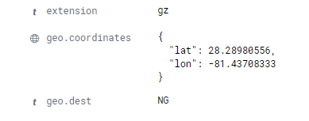
    2. 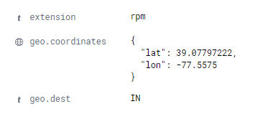
  + What OS was the source machine running?
    1. 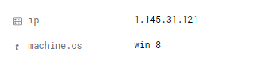
    2. 
  + What is the full URL that was accessed?
    1. 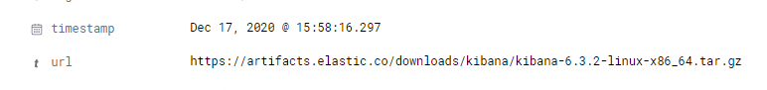
    2. 
  + From what website did the visitor's traffic originate?
    1. 
    2. 

1. Finish your investigation with a short overview of your insights.  
   * What do you think the user was doing?
     1. For the first (15:25, 74.184.0.240, NG, rpm package) - Seems as though this person was downloading a metricbeat rpm package.
     2. Fo the second (15:55, q.q45.31.121, CH, gz file) - Seems as though this person was downloading a Kibana archive/gzip file.
   * Was the file they downloaded malicious? If not, what is the file used for?
     1. Files themselves don’t appear to be malicious. One metricbeats, another kibana.
   * Is there anything that seems suspicious about this activity?
     1. The referrer URLs seem a little suspicious to me. Why would someone attempt to download metricbeat from facebook rather than the known source? Also seems odd that this person is downloading a .tar.gz file from a Win 8 OS onto a Win 8 OS...unless they’re running some sort of linux VM or dual boot setup with a shared directory.
     2. Referrer URL of www.elastic-elastic-elastic.com seems suspicious. Further investigation seems necessary on this one..
   * Is any of the traffic you inspected potentially outside of compliance guidelines?
     1. See above. Referral URLs seem a bit suspicious, and why download a .tar.gz file onto Win 8 OS?